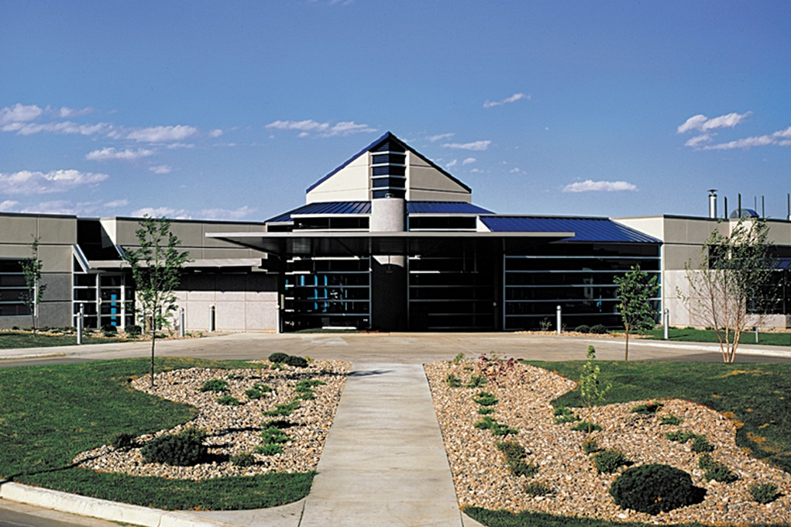

Same Day Surgery Center
Community Health Implementation Plan
FY 2020-2022
Released November 2019

Executive Letter
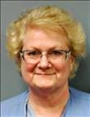
Doris Fritts
Executive Director

Same Day Surgery Center is committed to delivering the optimal surgical experience for our patient, physician, & employee customers, and supporting our community through the health care delivered and the taxes paid. In carrying out that purpose, we commit to improving the health of the community in collaboration with Regional Health (to be renamed Monument Health in 2020) through the strategies outlined in this Community Health Implementation Plan (CHIP).
Same Day Surgery Center looks forward to carrying out the activities of our CHIP during the next three years (FY 2020-2022). Carrying out this plan will require us to move beyond our own walls and increase collaborations with local stakeholders and community organizations. We are excited for this opportunity and look forward to how this work will help our patients and community live well.

Table of Contents
About Same Day Surgery Center 4
Community Health Improvement Overview 5
Community Health Needs Assessment Methodology 5
Identified Areas of Opportunity 5
Areas of Opportunity Not Chosen for Action 7
Health Priorities and Strategies July 1, 2019 – June 30, 2022 9
Priority 1: Cancer 9
Priority 2: Diabetes 10
Adoption of Community Health Implementation Plan 11

About Same Day Surgery Center

Same Day Surgery Center (SDSC), LLC, located in Rapid City, South Dakota, is a joint venture of Rapid City Regional Hospital, a tax exempt community hospital, and physicians comprising Rapid City Ambulatory Surgery, LLC. Established in July 2001 as a for-profit surgical specialty hospital, we are committed to delivering the optimal surgical experience for our patient, physician, & employee customers, and supporting our community through the health care delivered and the taxes paid. Despite our name, patients are able to spend multiple nights with us as long as medical necessity exists.

We serve about 3,900 patients per year through inpatient and outpatient surgery, of which about 33% are pediatric receiving ENT procedures and dental care. The vast majority of patients spending the night with us are females having gynecologic surgery or mastectomies. We also currently service podiatric, urologic, plastic and reconstructive, bariatric, oral and maxillofacial, ophthalmologic, and general surgery specialties. We have 6 licensed beds.

The mission of Same Day Surgery Center is to provide excellent surgical care in a safe, efficient environment with an emphasis on customer satisfaction. Same Day Surgery Center is dedicated to addressing its outreach objectives of serving the entire community, not only those who come through its doors. Building on a long tradition of service, the hospital utilizes its strengths alongside those of other well-established community partners. This strategy allows the hospital to better understand and reach the most vulnerable sectors of the community, while meeting pressing health care needs. The goal is to improve the community’s health status by empowering citizens to make healthy life choices.

Community Health Improvement Overview
In November 2018, Regional Health contracted with Professional Research Consultants (PRC) to conduct Community Health Needs Assessments (CHNA) for each of its hospital communities and the Same Day Surgery Center service area. The CHNA is a systematic, data-driven approach to determining the health status, behaviors, and needs of residents. The assessment provides information so that communities may identify issues of greatest concern and decide to commit resources to those areas, thereby making the greatest possible impact on community health status.

Community Health Needs Assessment Methodology
The CHNA report incorporates data from both quantitative and qualitative sources. Quantitative data input includes primary research (the PRC Community Health Survey) and secondary research (vital statistics and other existing health-related data); these quantitative components allow for trending and comparison to benchmark data at the state and national levels. Qualitative data input includes primary research gathered through an Online Key Informant Survey.
While this assessment is quite comprehensive, it cannot measure all possible aspects of health in the community, nor can it adequately represent all possible populations of interest. It must be recognized that these information gaps might in some ways limit the ability to assess all of the community’s health needs.

Identified Areas of Opportunity
The following “Areas of Opportunity” represent the significant health needs of the community, based on the information gathered through this Community Health Needs Assessment and the guidelines set forth in Healthy People 2020. From these data, opportunities for health improvement exist in the area with regard to the following health issues. (See also the summary tables presented in the following section).
Access to Healthcare Services | - Routine Medical Care (Children)  - Eye Exams
Cancer | - Cancer is the leading cause of death
Diabetes | - Ranked as a top concern in the Online Key Informant Survey
Heart Disease & Stroke | - Cardiovascular disease is a leading cause of death.  - Blood Pressure Screening  - Blood Cholesterol Screening
Injury & Violence | - Motor Vehicle Crash Deaths  - Firearm-Related Deaths  - Bicycle Helmet Use (Children 5-17)
Mental Health | - “Fair/Poor” Mental Health  - Symptoms of Chronic Depression  - Suicide Deaths  - Ranked as a top concern in the Online Key Informant Survey
Nutrition, Physical Activity & Weight | - Fruit/Vegetable Consumption  - Low Food Access  - Relied on Food Bank or Free Meals in the Past Year  - Overweight & Obesity (Adults)  - Medical Advice on Weight  - Ranked as a top concern in the Online Key Informant Survey
Potentially Disabling Conditions | - Joint replacement is the leading diagnosis for hospital admissions  - Caregiving
Sexually Transmitted Diseases | - Gonorrhea Incidence  - Chlamydia Incidence
Substance Abuse | - Cirrhosis/Liver Disease Deaths  - Illicit Drug Use  - Ranked as a top concern in the Online Key Informant Survey
Tobacco Use | - Cigarette Smoking Prevalence

Areas of Opportunity Not Chosen for Action
In acknowledging the wide range of priority health issues revealed through the CHNA process, Same Day Surgery Center determined it could only focus on those which it deemed most pressing, most under-addressed, and within the ability to influence. The areas identified during the CHNA process that will not be directly addressed through this implementation plan are listed below. These identified needs are being addressed by other organizations in the community, are outside our core area of expertise, or require resources that are not available at this time.
Health Priorities Not Chosen for Action | Reason
Access to Health Services | This issue will not be addressed as a primary need, but will be impacted through the Cancer & Diabetes priorities.
Heart disease and stroke | This issue will not be addressed as a primary need, but will be impacted through the Cancer and Heart Disease & Stroke priorities Regional Hospital’s CHIP.
Injury & violence | RH has partnered with Kohl’s Cares, Safe & Sound South Dakota, Farm Bureau of South Dakota, and Community Organized Resources in Educating Youth in order to address this area of opportunity. With these partnerships, SDSC determined that progress is being made in this area and that other areas of opportunity required more immediate and focused attention.
Mental health | This issue will not be addressed as a primary need, but will be impacted through the mental health priority of Regional Hospital’s CHIP.
Nutrition, Physical Activity, & Weight | This issue will not be addressed as a primary need, but will be impacted through the Cancer and Diabetes priorities.
Potentially Disabling Conditions | This issue will not be addressed as a primary need, but will be impacted through the Cancer and Diabetes priorities.
Sexually Transmitted Diseases | Data from the CHNA revealed that incidence rates of Chlamydia and Gonorrhea were of greatest concern in this area in the community. This information will be shared with primary care; however, this is not prioritized for action.
Substance Abuse | This issue will not be addressed as a primary need, but will be impacted through the mental health priority of Regional Hospital’s CHIP.
Tobacco Use | This issue will not be addressed as a primary need, but will be impacted through the Cancer and Heart Disease & Stroke priorities Regional Hospital’s CHIP.

Health Priorities and Strategies July 1, 2019 – June 30, 2022
In February 2019, the findings of the Community Health Needs Assessment (CHNA) were presented to the community groups including Live Well Black Hills, Community Services Connection, and Rapid City Community Conversations’ Healers and Transformers. These groups reviewed the areas of opportunity identified in the CHNA and provided input on potential priority areas of focus. Based on this feedback and the organization’s resources and expertise, Same Day’s Board of Directors determined the following two priority areas as the focus of the next Community Health Improvement Plan; Cancer and Diabetes.
Same Day Surgery Center and Regional Health commit to providing the resources necessary to carry out the goals, objectives, and strategies listed in this Community Health Implementation Plan. These resources include leadership and caregiver time and knowledge, financial support, and planning and reporting assistance.

Priority 1: Cancer

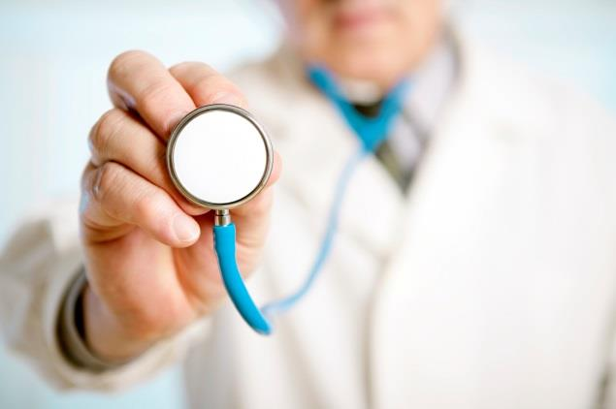
GOAL: Explore, develop, and support opportunities that will positively impact the health of our communities related to cancer prevention and care.

Objective: increase awareness of available cancer resources in our community
Anticipated Impact: Better understanding of services available
Strategies:
Implement Lifestyle Medicine to assist individuals and families to adopt and sustain healthy behaviors that affect health and quality of life
Participate in area wellness fairs, in collaboration with Dermatology and Mammography, to provide education on cancer screening opportunities.
Improve patient education materials and offerings
Partner with the Susan G Komen Foundation for education and awareness events

Priority 2: Diabetes

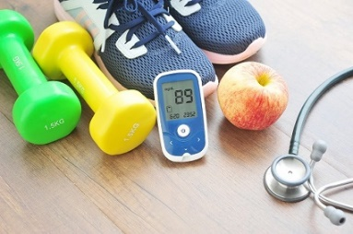
Goal: Explore, develop, and support opportunities that will positively impact the health of our communities related to diabetes.

Objective 1: increase community awareness of Diabetes prevention and management programs that promote healthy lifestyle choices
Anticipated Impact: Increased participation in health promotion programs and improved diabetic health outcomes
Strategies:
Provide screenings and education at community health fairs

Objective 2: Improve transition from inpatient to outpatient care

Anticipated Impact: Improved diabetic health outcomes
Strategies:
Utilize a system-wide approach to education and documentation in the electronic medical record
Provide education and equipment to patients

Integrate pharmacists in medication management for diabetes patients

Adoption of Community Health Implementation Plan

On October 10, 2019, the Same Day Surgery Center Board of Directors met and discussed this plan for addressing the selected community health priorities identified through the Community Health Needs Assessment process. Upon review, the Board approved this plan for Same Day Surgery Center and the related resources required to achieve the goals, objectives, and strategies outlined within that work to meet the health needs of the community.

