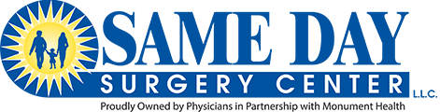
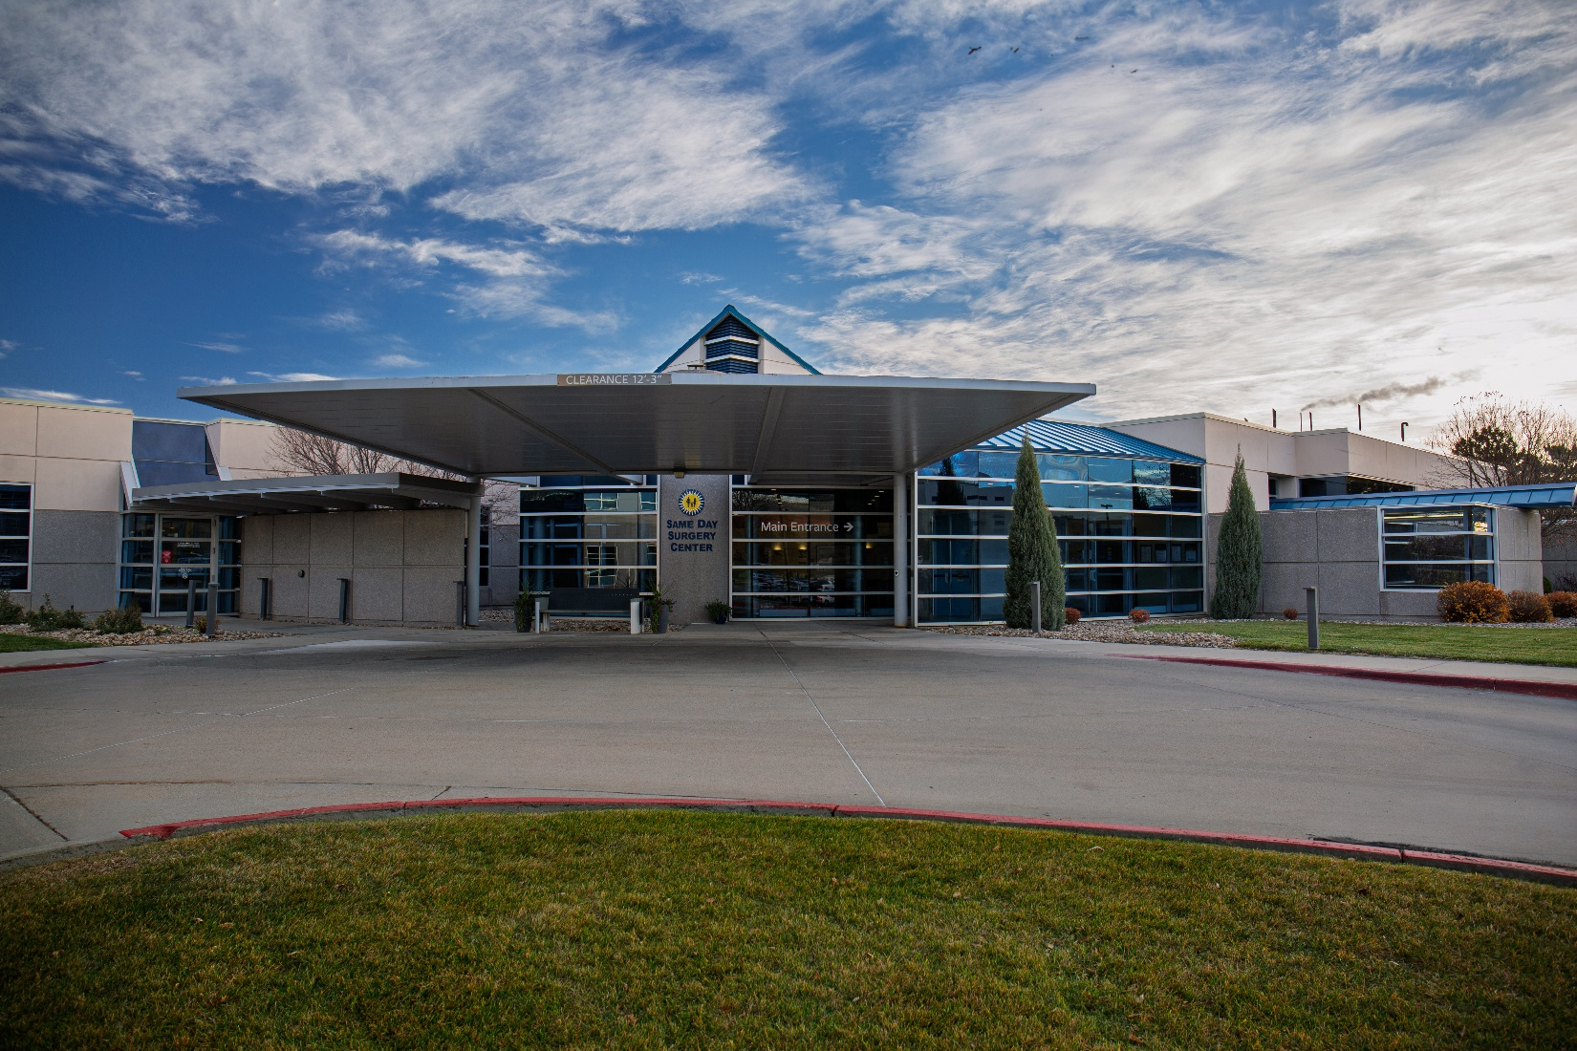

FY 2026-2028
  - Same Day Surgery Center
  - Community health implementation plan

Released November 2025

Executive LEtter
Same Day Surgery Center is committed to providing optimal surgical experience for our patients and physicians while supporting our community through the care we deliver and the taxes we contribute. In carrying out that purpose, we commit to improving the health of the community in collaboration with Monument Health through the strategies outlined in this Community Health Implementation Plan (CHIP).
Same Day Surgery Center looks forward to implementing the activities of our CHIP during the next three years (FY 2026-2028). Carrying out this plan will require us to move beyond our own walls and increase collaboration with local stakeholders and community organizations. We are excited about this opportunity and look forward to helping our patients and community live well.

ABOUT SAME DAY SURGERY CENTER
Same Day Surgery Center (SDSC), LLC, located in Rapid City, South Dakota, is a joint venture of Monument Health Rapid City Hospital, a tax-exempt community hospital, and physicians comprising Rapid City Ambulatory Surgery, LLC. Established in July 2001 as a for-profit surgical specialty hospital, we are committed to delivering the optimal surgical experience supporting our community through the health care delivered and the taxes paid. Despite our name, patients can spend multiple nights with us if medical necessity exists.
We serve about 4,000 patients per year through inpatient and outpatient surgery, of which about 33% are pediatric receiving ENT procedures and dental care. Patients spending the night with us usually do so after undergoing gynecology, urology, bariatric, or colon surgery. We also currently service endoscopic, plastic and reconstructive, oral and maxillofacial, orthopedic, podiatry, and general surgery specialties. We have 6 licensed beds.
The mission of Same Day Surgery Center is to provide compassionate expert surgical care in a safe and comfortable environment tailored to each patient’s needs. Same Day Surgery Center is dedicated to addressing its outreach objectives of serving the entire community, not only those who come through its doors. Building on a long tradition of service, the hospital utilizes its strengths alongside those of other well-established community partners. This strategy allows the hospital to better understand and reach the most vulnerable sectors of the community while meeting pressing health care needs. The goal is to improve the community’s health status by empowering citizens to make healthy life choices.

COMMUNITY HEALTH IMPROVEMENT OVERVIEW
In November 2024, Monument Health and Same Day Surgery Center contracted with Professional Research Consultants (PRC) to conduct Community Health Needs Assessments (CHNA) for each of its hospital communities including the Same Day Surgery Center service area. The CHNA is a systematic, data-driven approach to determining the health status, behaviors and needs of residents. The assessment provides information so that communities may identify issues of greatest concern and prioritize resources to those areas, thereby making the greatest possible impact on community health status.

CHNA Methodology
The CHNA report incorporates data from both quantitative and qualitative sources. Quantitative data input includes primary research (the PRC Community Health Survey) and secondary research (vital statistics and other existing health-related data); these quantitative components allow for trending and comparison to benchmark data at the state and national levels. Qualitative data input includes primary research gathered through an Online Key Informant Survey.
While this assessment is quite comprehensive, it cannot measure all possible aspects of health in the community, nor can it adequately represent all possible populations of interest. It must be recognized that this information gaps might in some way limit the ability to assess all the community’s health needs.

IDENTIFIED AREAS OF OPPORTUNITY
The following “Areas of Opportunity” represent the significant health needs of the community, based on the information gathered through this Community Health Needs Assessment and the guidelines set forth in Healthy People 2030. From this data, opportunities for health improvement exist in the area regarding the following health issues. (See also the summary tables presented in the following section).

CANCER | ▪ Leading Cause of Death  ▪ Cervical Cancer Screening
NUTRITION, PHYSICAL ACTIVITY & WEIGHT | ▪ Food Insecurity  ▪ Low Food Access  ▪ Overweight & Obesity [Adults]

COMMUNITY HEALTH IMPROVEMENT OVERVIEW

Areas of opportunity not chosen for action
In acknowledging the wide range of priority health issues revealed through the CHNA process, Same Day Surgery Center determined it could only focus on those which it deemed most pressing, most under-addressed, and within the ability to influence. The areas identified during the CHNA process that will not be directly addressed through this implementation plan are listed below. These identified needs are being addressed by other organizations in the community, are outside our core area of expertise or require resources that are not available at this time.

ACCESS TO HEALTH CARE SERVICES | ▪ Lack of Health Insurance  ▪ Barriers to Access: Cost of Prescriptions, Cost of Physician Visits, Appointment Availability, Difficulty Finding a Physician  ▪ Lack of Financial Resilience  ▪ Emergency Room Utilization  ▪ Ratings of Local Health Care
DIABETES | ▪ Diabetes Deaths  ▪ Prevalence of Borderline/Pre-Diabetes  ▪ Key Informants: Diabetes ranked as a top concern.
HEART DISEASE & STROKE | ▪ Leading Cause of Death  ▪ High Blood Pressure Prevalence  ▪ Overall Cardiovascular Risk
HOUSING | ▪ Housing Insecurity  ▪ Housing Conditions  ▪ Experience of Homelessness  ▪ Key Informants: Social Determinants of Health (especially Housing) ranked as a top concern.
INFANT HEALTH & FAMILY PLANNING | ▪ Infant Deaths  ▪ Teen Births
INJURY & VIOLENCE | ▪ Motor Vehicle Crash Deaths  ▪ Falls [Age 65+] Deaths  ▪ Violent Crime Experience  ▪ Intimate Partner Violence
MENTAL HEALTH | ▪ “Fair/Poor” Mental Health  ▪ Diagnosed Depression  ▪ Symptoms of Chronic Depression  ▪ Stress  ▪ Suicide Deaths  ▪ Receiving Treatment for Mental Health  ▪ Difficulty Obtaining Mental Health Services  ▪ Key Informants: Mental Health ranked as a top concern.
ORAL HEALTH | ▪ Dental Insurance Coverage
RESPIRATORY DISEASE | ▪ Asthma Prevalence [Adults]
SEXUAL HEALTH | ▪ Chlamydia Incidence  ▪ Gonorrhea Incidence
SUBSTANCE ABUSE | ▪ Alcohol-Induced Deaths  ▪ Cirrhosis/Liver Disease Deaths  ▪ Unintentional Drug-Induced Deaths  ▪ Illicit Drug Use  ▪ Key Informants: Substance Use ranked as a top concern.
TOBACCO USE | ▪ Use of Vaping Products

Health Priorities and Strategies

July 1, 2026 – June 30, 2028
In April 2024, the findings of the Community Health Needs Assessment (CHNA) were shared with Monument Health leadership, with Same Day Surgery leadership getting the information the following month. These groups reviewed the areas of opportunity identified in the CHNA and provided input on potential priority areas of focus.

Based on this feedback and the organization’s resources and expertise, Same Day Surgery Center’s Board of Directors determined the following two priority areas as the focus of the Community Health Improvement Plan:

- Cancer
- Nutrition, Physical Activity and Weight

Same Day Surgery Center and Monument Health commit to providing the resources necessary to carry out the goals, objectives, and strategies listed in this Community Health Implementation Plan. These resources include leadership and caregiver time and knowledge, financial support, and planning and reporting assistance.

Priority 1: Cancer

GOAL: Explore, develop, and support opportunities that will positively impact the health of our communities related to cancer prevention, treatment, and survivorship.

OBJECTIVE 1: INCREASE awareness of available cancer resources in our community
Anticipated Impact: Gain better community understanding of the Cancer Care services available

STRATEGIES:
- Provide Screenings and Education at Community Health Fairs/Events
- Improve patient education materials, offerings, and practices to focus on the importance of cancer prevention and early detection to reduce cancer incidence in our region
- Participating in Cancer Fundraisers and Awareness Walk(s)

Priority 2: Nutrition, PHysical Activity and Weight

GOAL: Explore, develop, and support opportunities that will positively impact on the health of our communities related to nutrition and exercise.

OBJECTIVE 1: Increase community awareness of nutritional and exercise resources and management programs that promote healthy lifestyle choices.
Anticipated Impact: Increase participation in health programs and improve diabetic health outcomes.

STRATEGIES:
- Provide screenings and education at community health fairs/events
- Participate in food drives and distribution for food-insecure populations
- Encourage physical activity through community activities

Adoption of Community Health Implementation plan
In October 2025, the Same Day Surgery Center Board of Directors met and discussed this plan for addressing the selected community health priorities identified through the Community Health Needs Assessment process. Upon review, the Board approved the adoption of this plan for Same Day Surgery and the related resources required to achieve the goals, objectives and strategies outlined within that work to meet the health needs of the community.

“Corporation is well-equipped to achieve its strategic objectives and drive long-term successes”

